Week 6 – Hardware Development Update

Document Version Number: 4.0

Date: April 5, 2015

Author: Yu Chen Xu

Revised: Eric Vuong

Hardware Version: 4.0

Goal: To explain the updated version of physical model.

Contents

Ball initial shooting angle 2

Supporting pieces 3

Height 3

Loading supporting pieces 4

# Ball initial shooting angle

In this week, the major mechanical update is the increase of the angle of the ball resting place.

Before

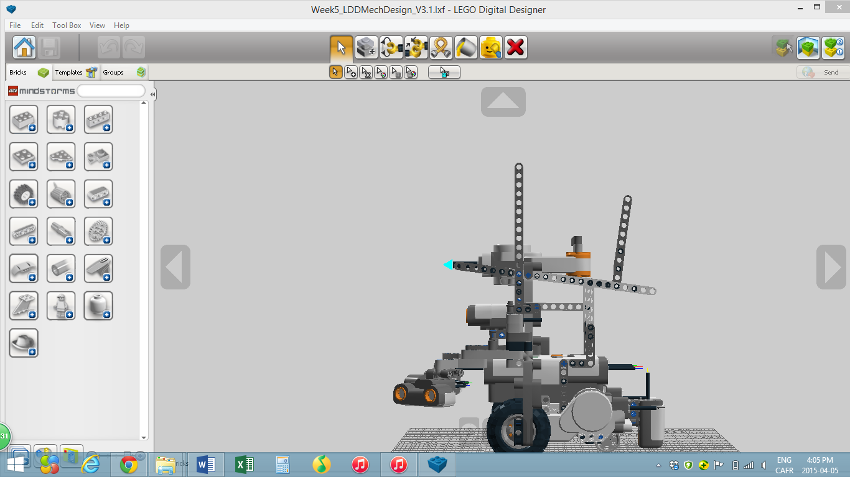

After

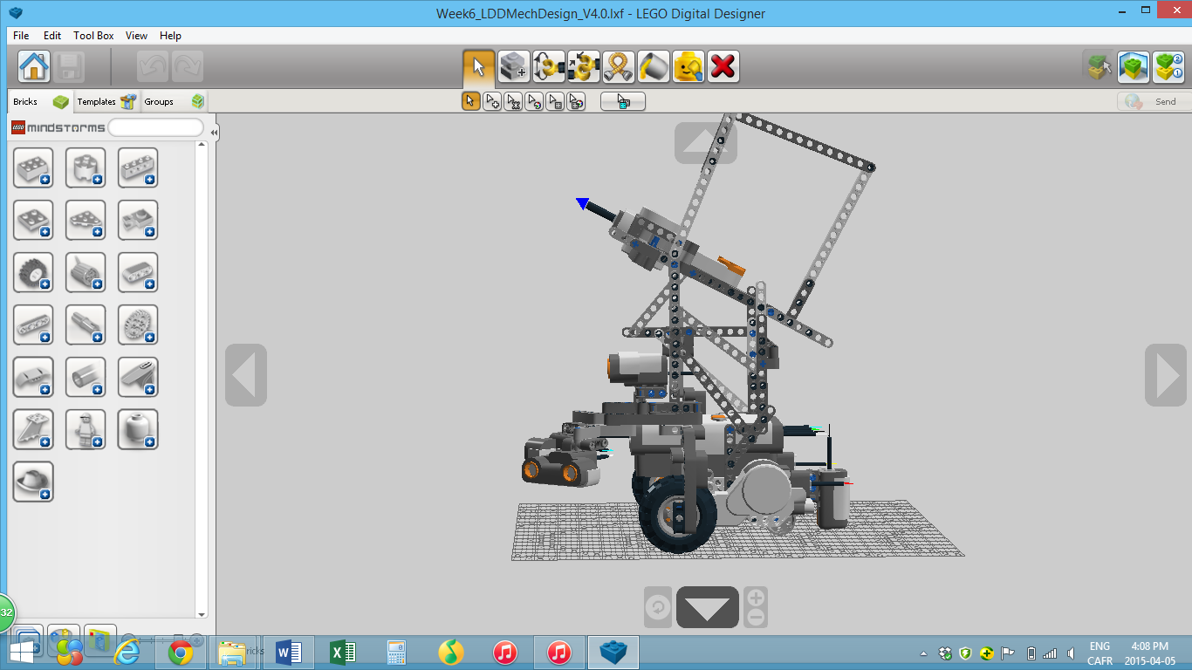

As observed, the angle at which the motor hits the ball is a little bit increased. The reason of this change is to be able to hit some targets placed near the wall enclosure. In the previous hardware version, the initial angle is almost parallel to the ground level. Therefore, the ball will have a trajectory like this.

In fact, to hit those targets, the ball needs to have a parabolic trajectory.

The newest version will be able to shoot the ball in such trajectory.

# Supporting pieces

Since the 1st hardware version, the launching part of the robot has never been very stable, as it can shake left-right and front-back. Therefore, in order to stabilize the launcher, a lot of additional sticks are used. Those pieces will make the robot more secure and solid.

As shown, pieces in yellow are added to secure the robot.

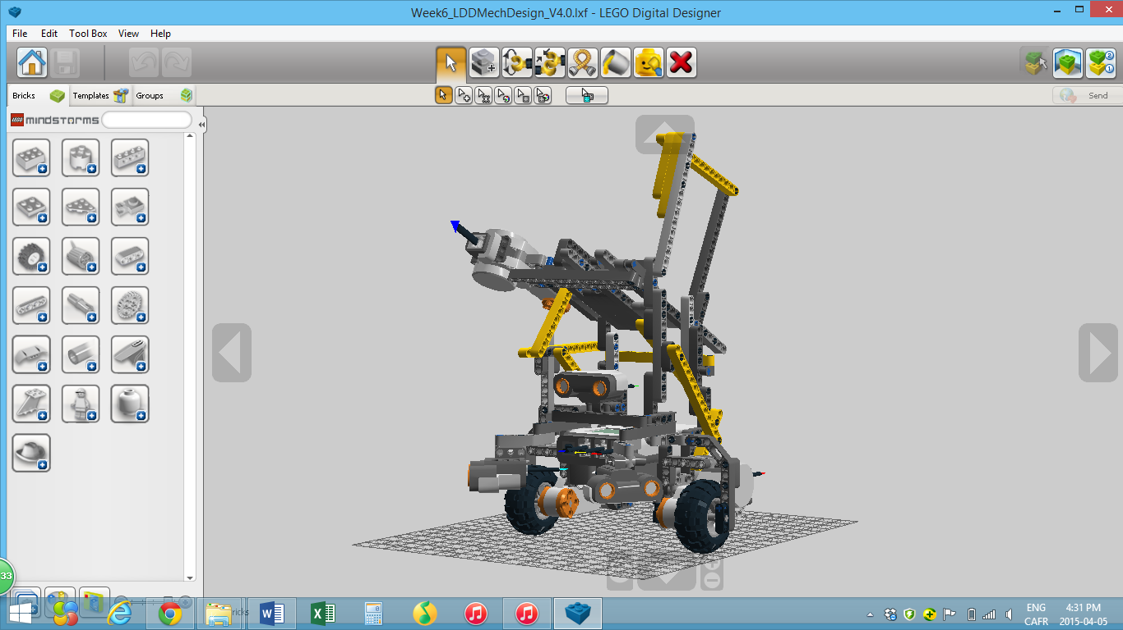

# Height

For the competition, the launcher needs to shoot the ball over the wall. However, in the previous mechanical models, the team didn’t take that requirement into account. Therefore, a simple modification will be done. The launcher will be higher up by 10 LEGO blocks, approximately 7cm.

# Loading supporting pieces

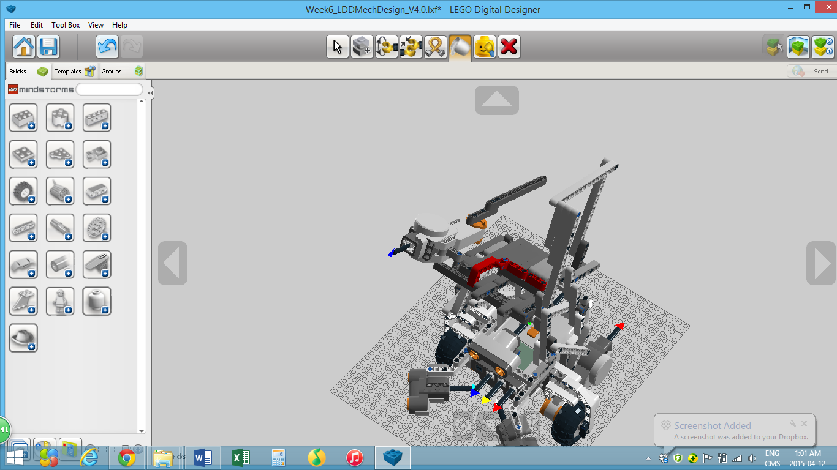

The piece in red are added to make sure that the ball doesn’t fall away from the resting zone after being loaded.